**ASSIGNMENT-3**

1. write a SQL query to find Employees who have the biggest salary in their Department

Ans.

Select d.dept_name as department_name ,max(e.salary) as max_salary From

Employee as e, Department as d

Where e.dept_id=d.dept_id

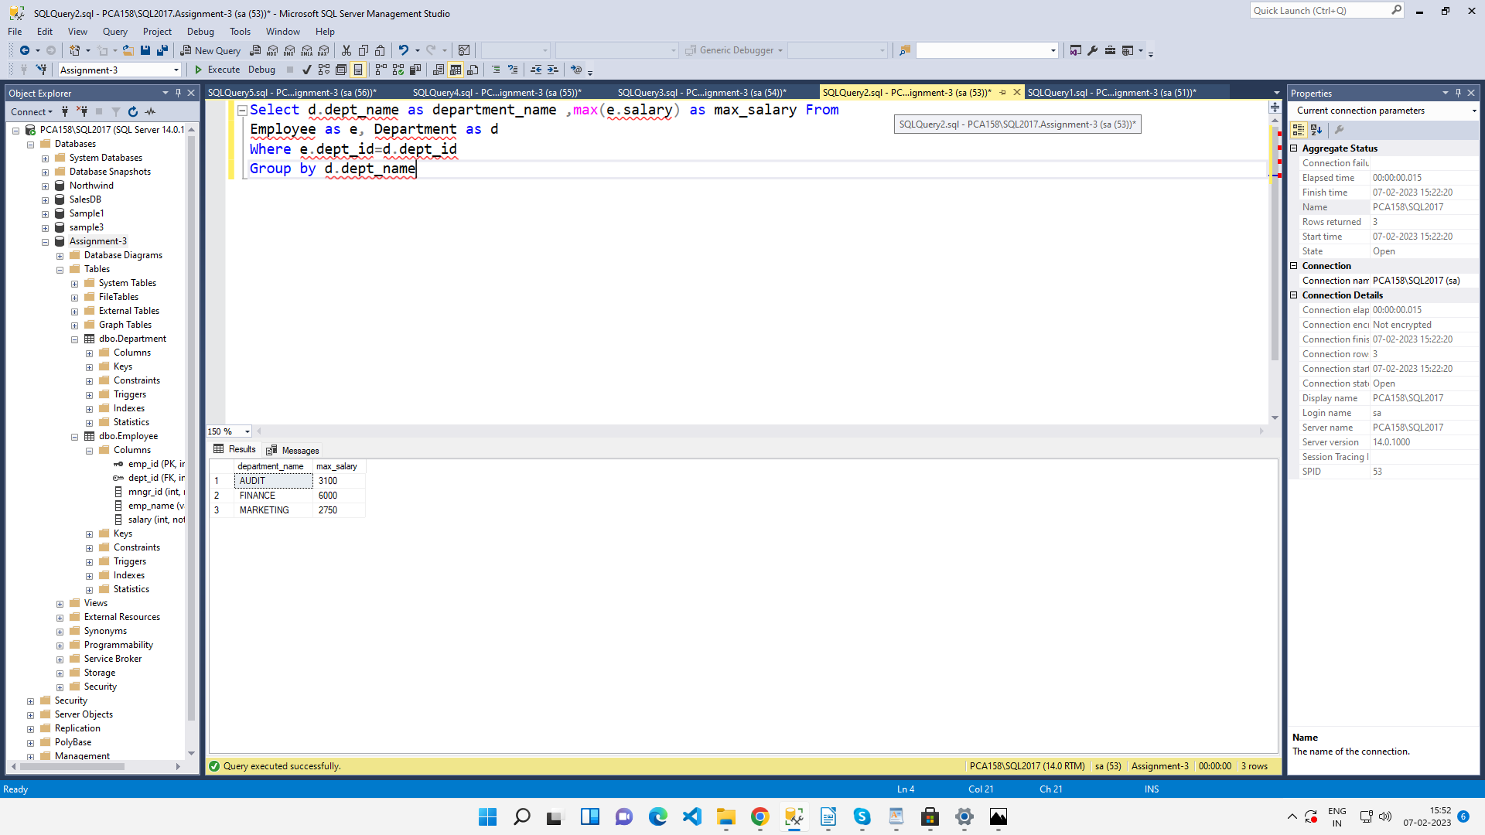Group by d.dept_name

2. write a SQL query to find Departments that have less than 3 people in it

Ans.

select d.dept_name, COUNT(e.emp_id) AS NumberOfpeople FROM Employee as e,

Department as d where e.dept_id= d.dept_id

GROUP BY (d.dept_name)

having COUNT(e.emp_id)<=3;

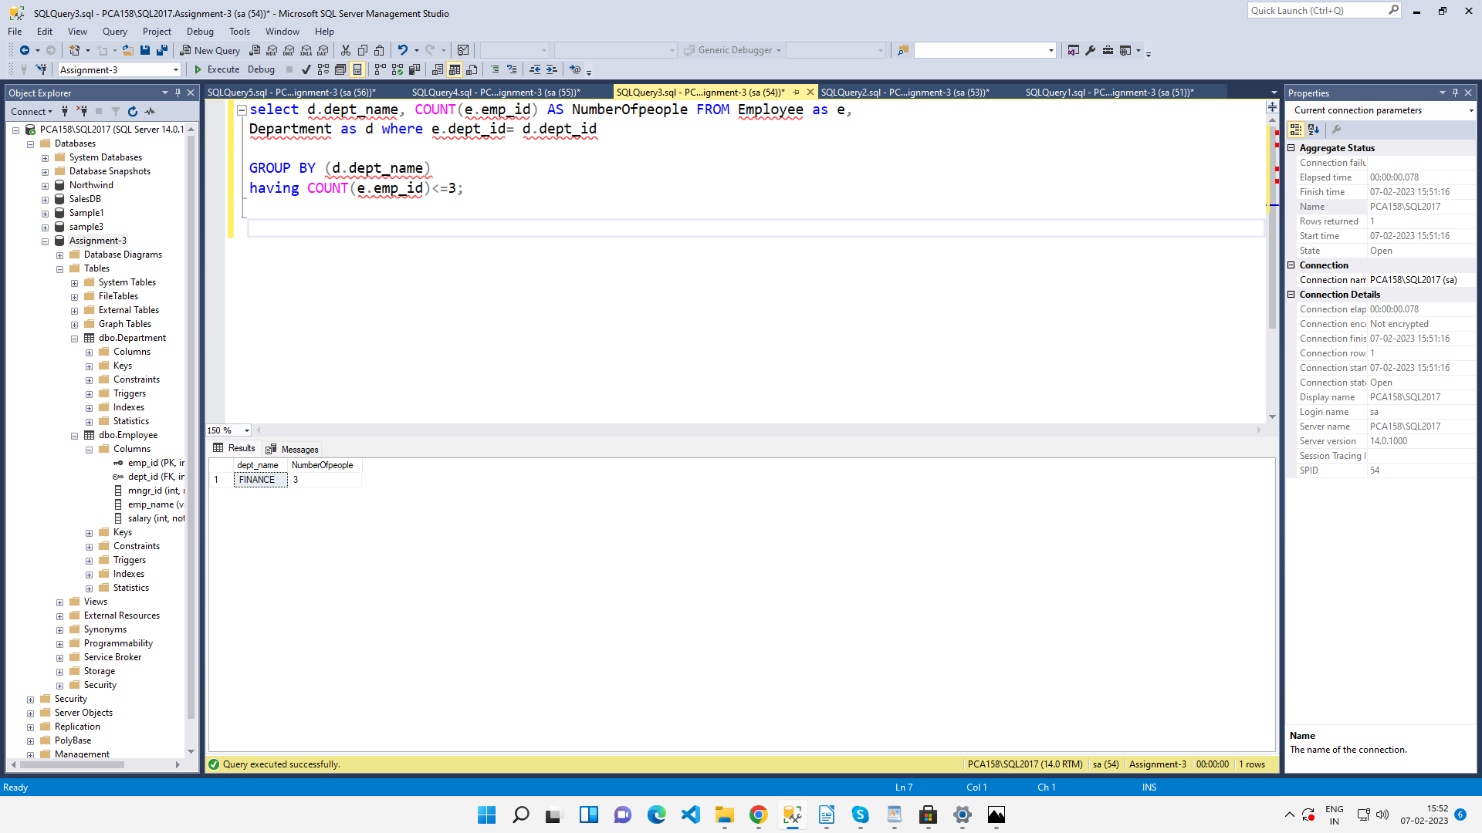

3. write a SQL query to find All Department along with the number of people there

Ans.

SELECT d.dept_name, COUNT(e.emp_id) AS NumberOfOrders FROM Employee as e, Department as d

Where e.dept_id= d.dept_id

GROUP BY dept_name;

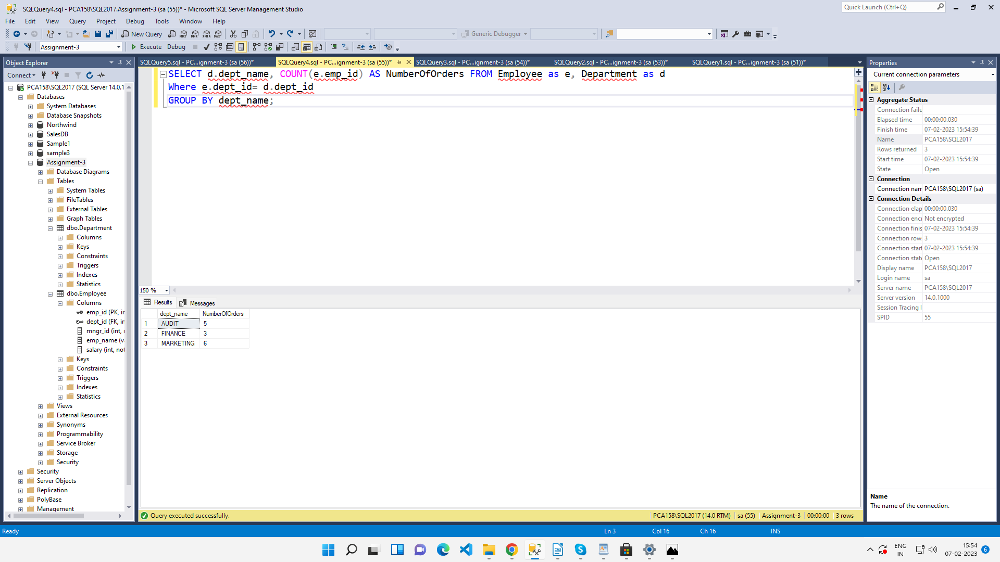

4. write a SQL query to find All Department along with the total salary there

Ans.

SELECT d.dept_name, SUM(e.salary) AS total_salary FROM Employee as e, Department as d

Where e.dept_id= d.dept_id

GROUP BY dept_name;

